Promotion Resources
We try our best to get your promotions up in a timely manner, to give us enough lead time, please plan to send any information and requests at a minimum of 2 weeks ahead of time.

For all requests listed below, please email: cobe-info@boisestate.edu and include "STUDENT ORG REQUEST" in the subject line.
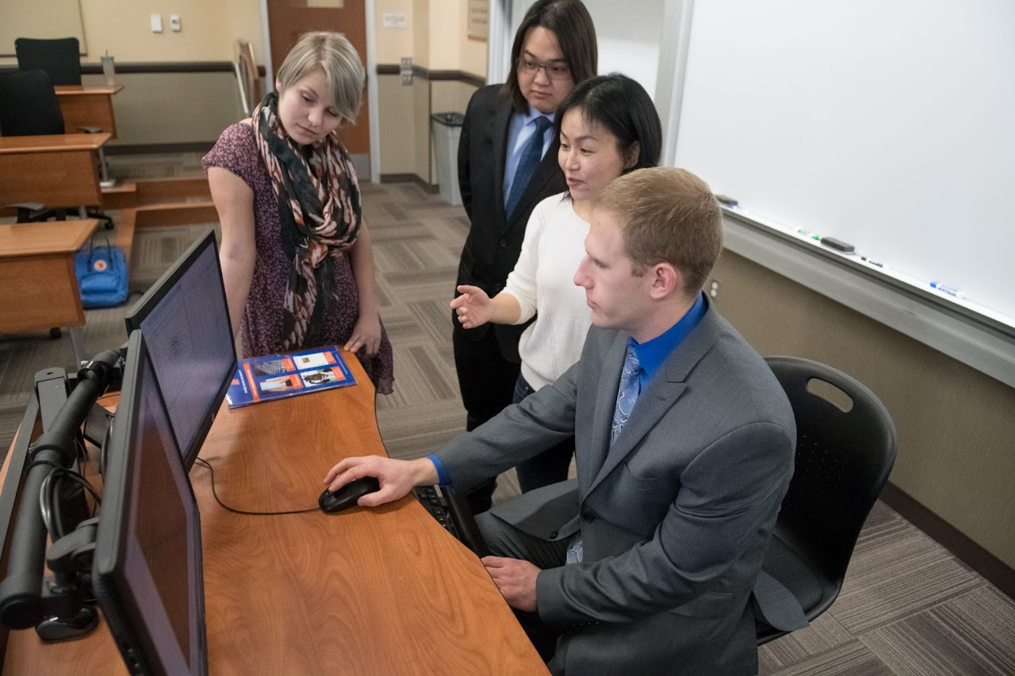

COBE Website
For all website updates, send requests to cobe-info@boisestate.edu with the subject line, "STUDENT ORG REQUEST."
- Be very clear and include all of the information that needs to be changed on your organization webpage.
- To update your student organization listing on the COBE Student Organization page, send what information needs to be changed.
- If your event is open to all students, we can put it on the events page on the COBE website. Send all of the event information at least 2 weeks in advance.

Digital Display Ads (Touchscreens throughout the MBEB)
For digital displays, send requests to cobe-info@boisestate.edu with the subject line, "STUDENT ORG REQUEST."
- Submit a JPG or PNG file 1920 px wide X 1080 px high, 72 ppi.
- There is a Boise State logo on the screen already, so you do not need to have a Boise State logo in your image.
- Ads rotate every 15 seconds. Keep text to a minimum.
- If you have a lot of white at the edges of your ad, please outline the ad. Images look better with defined edges.
- Name your file with what the ad is about, the start date and end date. Also, include the start and end date in the body of the email when you send the file.
- If you want your digital display ad up for 2 weeks prior to your event, please email the graphic 4 weeks prior to the event date. If you want it up 1 week prior to your event, email the graphic 3 weeks prior to the event date.
- Ads should follow Boise State brand standards.

COBE News
For all COBE news stories, send requests to cobe-info@boisestate.edu with the subject line, "STUDENT ORG REQUEST."
- Share your news, accomplishments and announcements with us. It may be featured in the COBE news on our website.

Printing Posters
For all poster printing needs, send requests at least 2 weeks in advance to cobe-info@boisestate.edu with the subject line, "STUDENT ORG REQUEST."
- Make poster in InDesign or another graphic design software. Make the paper size in your file 24 x 31 (this is the size of our plasti-core boards) - the printer does not print to the edge of the paper; there will be white on all sides.
- When sending the poster file, please include via email, the timeline for printing the poster and your organization funding string (FDCC).
- Organizations may borrow poster boards and easels from the Dean's Office and must be returned.
- COST:
  - Uncoated 24 x 31 $8 (student pricing discount)
  - Semi-gloss 24 x 31 $12

Social Media Posts on COBE Accounts
For all social media posts, send requests at least 2 weeks in advance to cobe-info@boisestate.edu with the subject line, "STUDENT ORG REQUEST."
Send appropriate graphic that is within Boise State brand guidelines, caption details and if your organization has a social media account to tag in the post. Please indicate whether your social media post is best suited for LinkedIn, Instagram or Facebook.

Email Communication
For all email communication needs, send requests ASAP to cobe-info@boisestate.edu with the subject line, "STUDENT ORG REQUEST."
COBE student organizations may request their events be included in a COBE upcoming events emailing. There is no set schedule for event emailings. We cannot guarantee that your event promotion schedule will coincide with an event emailing. Your best chance of getting your event included in one of the COBE upcoming event emailings is to request inclusion ASAP.
Send the following to the cobe-info email:
- An email address for requests for more information
- Event description (entice people to come), date, time, place, registration link if required and photo
- Emails cannot be sent with attachments

Flyers
You may hang flyers on the bullet boards throughout the MBEB; you are not allowed to tape or hang flyers on the walls, windows, doors, etc. throughout the building. It is your responsibility to take down the flyers that you put up after your event.

Campus Digital Screens
- Library Digital Screens - 1280 x 720 px, File type: jpg. To submit, contact Luan Teed
- Rec Center Digital Screens - 1920 x 1080 px, File type: jpg. To submit, contact Jared Cox
- On-Campus Housing Digital Displays - 1920 x 1080 px, organizations can submit one page PPT or PDF files (landscape preferred) to be uploaded to the digital displays located behind the six service desks across the Boise State residential community. To submit a request, fill out a marketing submission form

SUB (Student Union Building) Promotions
Submit all promo requests and materials here. For questions, email subpromos@boisestate.edu.
- Toilet Talk - Promotions in over 150 stalls in the bathrooms of the SUB. Submit materials by the last Thursday of the month to secure a spot for the following month. Promos switch out every month. Requirements: must be a 1000 x 1000 px jpg file.
- Social Media - Content can be submitted and shared on the SUB Facebook and Instagram pages. You may regularly submit graphics, milestones, organization events/updates, etc. Note: Not all requests will be posted, depending on the schedule and other approved content.
- Digital Displays - 4 digital screens in the SUB first floor dining - size 768 x 1366 px jpg and 2 60" screens behind the Info Desk, 6 24" kiosk on SUB 1st floor and 2nd floor - size 1920 x 1080 px jpg. For all digital signage: submit requests 1 1/2 weeks before desired promo start date.

Other Campus Promotions
To promote your organization or event in other buildings on campus, contact the specific building/department for permission and specific directions on what is allowed in their building. Each building varies on best practices and processes for event and organization promotion. This is a flyering route we utilize.

Promoting your Event
Check out COBE Dean's Office resources for promoting your organization/event.

Room Reservations
- To reserve first floor classrooms in the MBEB, contact the registrar's office to schedule.
- For all other rooms in the MBEB, contact Gail Puccetti in room 1213B, email her at gailpuccetti@boisestate.edu or call her at (208) 426-3159.

COBE Career Services Involvement
Student organizations can collaborate with COBE Career Services to host employer information sessions, workshops, and events. Email Career Services.

Need tongs, bowls, etc. for serving food at your event?
Contact the Dean's Office GA at cobe-info@boisestate.edu, subject "STUDENT ORG REQUEST" to schedule a time to come to the Dean's Office and check out what is available for use.

Want to invite the dean to your event?
Please extend invitations to the dean three weeks before the event date by contacting the Dean's Office at cobe-info@boisestate.edu, subject "STUDENT ORG REQUEST." Make sure all event details are included in the email.

